RESUME
Chandra Pratap Singh
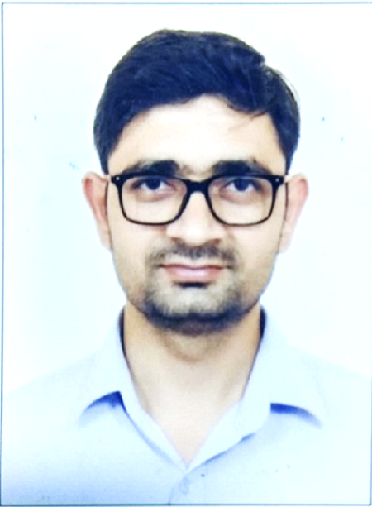
H. No. B-58, Sector 49
Noida (U.P)
+91-8510079990
Singh.cp91@gmail.com
Mr. Chandra has 5-year experience in the field of Civil Engineering. He had worked on Autocadd, estimation, detailing and execution for building management during entire work experiences. He has been involved in the environmental engineering field during his M. Tech. at Jamia Millia Islamia University for Namami Gange project initiated by NGT. Where he carried out inspection for different 24 nos. industries (incl. sugar, distillery, dairy, chemical, pharmaceutical, food and beverage) to monitor their ETPs performance and effluent quality check and also for obtaining NOC for . He has presented a review paper on modular construction technologies in international conference organized at Jamia in December 2016. He has published total 3 nos. technical review papers on different topics. Currently, he is looking for opportunity to work with an organization working against the challenges in the field of Environmental Science & Engineering. He has completed undergraduate degree as B. Tech (Civil Engineering) from Gautam Buddh Technical University, Lucknow (formerly U.P.T.U) and postgraduation as M.Tech (Environmental Science & Engineering) from Jamia Millia Islamia, Central University, New Delhi which is likely to be completed by the end of December-2018.
Professional Experiences
OFFICE OF THE RESIDENT COMMISSIONER OF GUJARAT
(GUJARAT BHAWAN, NEW DELHI), Since December - 2013
Assistant Engineer (Civil)
Mr. Chandra is working for office of Chief Administrative Officer and currently looks after civil works of entire bhawan building and executed various works related to civil works as listed below. He has been involved in supervising the manpower and dealing with the contractors and suppliers for day to day maintenance and major maintenance works in the premises.
- Annual repair, painting, maintenance & additional alteration works at Gujarat Bhawan (appx. tender cost Rs.80.0 lacs.) for year 2018-19
- Annual repair, maintenance & additional alteration works at Gujarat Bhawan (appx. tender cost Rs. 1.08 cr.) for year 2017-18
- Strengthening of top roof Cantilever Structure on all faces & four sides and Waterproofing of top roof of Main Building at Gujarat Bhawan, New Delhi (40.0 lacs) for year 2016-17
- Annual repair, maintenance & additional alteration works at Gujarat Bhawan (appx. tender cost Rs. 1.30 crores) for year 2015-16
- Providing roller blind above VVIP entry on glasses face Main Building near Reception at Gujarat Bhawan (appx. tender cost Rs. 1.25 lacs) for year 2014-15
- Providing false ceiling gypsum perforated tiles at R.C office Gujarat Bhawan (appx. Tender cost 1.2 lacs) for year 2014-15
- Other maintenance works at Gujarat Bhawan like execution of the renovation of VIP guest rooms, restaurant, C.M suite & staff accommodation etc.
- Modification of Server Room & provision of new sitting room behind main building close to VIP kitchen at Guarat Bhawan (appx. tender cost Rs. 4.5 lacs) for year 2014-15
- Installation of High Roof Dome at Gujarat Bhawan, New Delhi (appx. tender cost Rs. 52 lacs) for year 2013-14
- Annual repair, maintenance & additional alteration works at Gujarat Bhawan (appx. tender cost Rs. 1.20 crores) for year 2014-15
- Annual Repair & Maintenance of Boundary Walls & Staff Quarters at Gujarat Bhawan, New Delhi (appx. tender cost Rs. 16 lacs) for year 2013-14
Education & Certificates
Year | Name of degree | University/Board | Institution | Percentage/CGPA | Remarks
2018 | M. Tech (Environmental Science and Engg.), Part Time - Regular | JMI, New Delhi | F/o Engineering and Technology | 8.54 | Last Semester Result awaiting
2018 | 3rd Year |  |  | 9.13  (5th Sem.) | Last Semester Result awaiting
2018 | 2nd Year |  |  | 9.17 | Last Semester Result awaiting
2018 | 1st Year |  |  | 7.62 | Last Semester Result awaiting
2013 | B. Tech (Civil Engg.) | GBTU (formerly UPTU), Lucknow | Radha Govind Engg. College, Meerut | 70.26% | 1st DIV.
2009 | Intermediate | UP Board | Janta Int. College | 56.8% | 2nd Position
2007 | High School | UP Board | Janta Int. College | 57.5% | 2nd Position

Other qualifications
- GATE (2013 & 2014) qualified
- Qualified written test and interviewed for the position of Deputy Engineer (Civil) at Bharat Electronics in 2014 but could not be selected.
Computer Skills
- AUTOCADD All Versions, Microsoft Office
Publications
- Presented a technical paper entitled “Role of Civil Engineer in Disaster Mitigation” in National Seminar on Disaster Management (NSDM-2012), November 2012.
- Published a technical paper entitled “Shotcrete – Advanced Technology in Civil Engineering” in the Journal of Civil Engineering and Environment Technology (JCEET) i.e. 4th International Conference on “Advances in Architecture, Urban Planning, Material Engineering and Civil/Environment Dynamics” (AUPMECED-2014), at Jawaharlal Nehru University, New Delhi. 26th & 27th July 2014.
- Published and Presented a technical paper entitled “Modular Construction – A Sustainable Construction Technology” in International Conference and Exhibition on Building Utilities (ICEBU) at Jamia Millia Islamia Central University, New Delhi, 1st, 2nd & 3rd - December, 2016.
Certificates
- Foundation course in AUTOCADD 2010 at CADD Center, Meerut, 2011
- Gujarati language certificate, scored first position at Gujarat Bhawan, May – 2018
Language known
Hindi, English, Urdu and Gujarati
Marital Status
Unmarried
References for any information stated above are readily available on demand.

Chandra Pratap Singh

